NuWa
Windows CE.NET 4.2
Technical Manual
(Version 1.0)

Warranty
All products manufactured by ICPDAS Inc. are warranted against defective materials for a period of one year from the date of delivery to the original purchaser.

Warning
ICPDAS Inc. assumes no liability for damages consequent to the use of this product. ICPDAS Inc. reserves the right to change this manual at any time without notice. The information furnished by ICPDAS Inc. is believed to be accurate and reliable. However, no responsibility is assumed by ICPDAS Inc. for its use, or for any infringements of patents or other rights of third parties resulting from its use.

Copyright
Copyright by ICPDAS Inc., LTD. All rights reserved worldwide.

Trademark
The names used for identification only maybe registered trademarks of their respective companies.

License
The user can use, modify and backup this software on a single machine. The user may not reproduce, transfer or distribute this software, or any copy, in whole or in part.
Contents
- Tutorials of Windows CE.NET 4.2 ………………... 3
- NuWa BSP ……………………………………………. 4
  - Installation of BSP ………………………………. 4
  - Create a new platform for NuWa ……………… 7
  - Download OS Image to NuWa ……………….. 13
- NuWa Utility ………………………………………… 16
  - Save Registry …………………………………... 16
  - System Configure ……………………………… 17
  - Auto Execution ………………………………… 18
  - Version Update …………………………………. 18
  - About …………………………………………….. 19
- Installation of NuWa SDK ………………………… 20
- Miscellaneous …………………………………....… 25
  - Boot Loader …………………………………….. 25
  - JTAG ……………………………………………... 26
  - Debug Port ……………………………………… 27
Appendix A: Device Name of Serial Ports ………… 28
- Tutorials of Windows CE.NET 4.2
Microsoft® Windows® CE .NET is an open, scalable, 32-bit operating system (OS) that is designed to meet the needs of a broad range of intelligent hardware devices, from enterprise tools such as industrial controllers, communications hubs, and point-of-sale (POS) terminals to consumer products such as cameras, Internet appliances, and interactive televisions. A typical Windows CE–based embedded platform is targeted for a specific used, often runs disconnected from other computers, and requires a small-sized OS that has a bundled, deterministic response to interrupts.
Windows CE .NET offers the application developer the ease and versatility of scripting languages, along with the versatile environment of the Microsoft Win32® application programming interface (API). It also offers bundled support for multimedia, Internet, LAN, and mobile communications and security services.

The following image map shows the Windows CE .NET OS architecture.
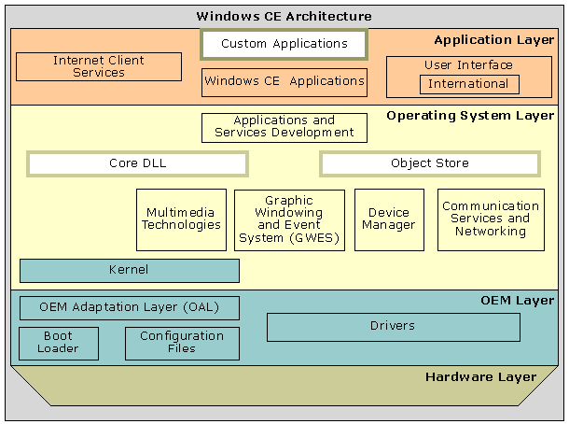
For more information, please refer to Microsoft MSDN
- NuWa BSP
A board support package (BSP) is the main part of a Microsoft® Windows® CE-based platform and contains source files, binary files, or both. The BSP creation process involves developing a boot loader, developing an OEM adaptation layer (OAL), creating device drivers, and modifying platform configuration files.
Using the BSP you can migrate or update it to be fully compatible with the features in Windows CE .NET 4.2.
  - Installation of BSP
Please close Windows CE.NET 4.2 Platform Builder before install NuWa BSP.

The following step illustrate BSP installation guide:
Step 1: Double click NUWA_BSP.MSI package file to install BSP. Then click “Next”.
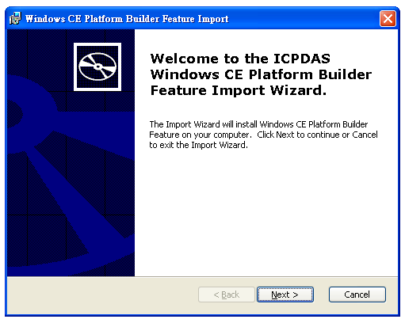
Step 2: Ready to Install BSP. Click “Install”.
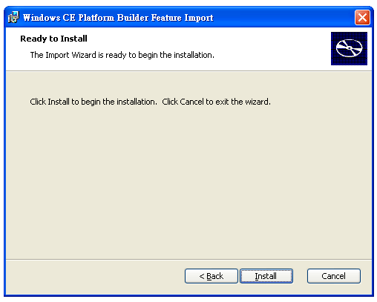

Step 3: Installing BSP and copy files.
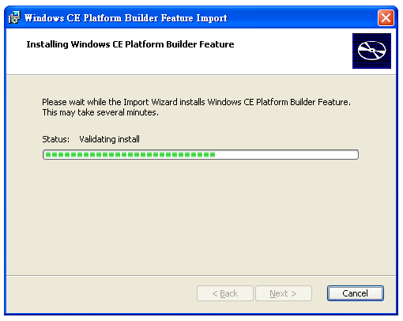
Step 4: BSP Installation finished.
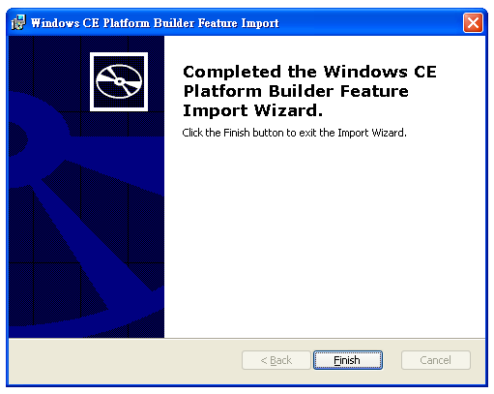

Once we completed all of “Installation of BSP” steps, we will get NUWA BSP on Catalog of Platform Builder
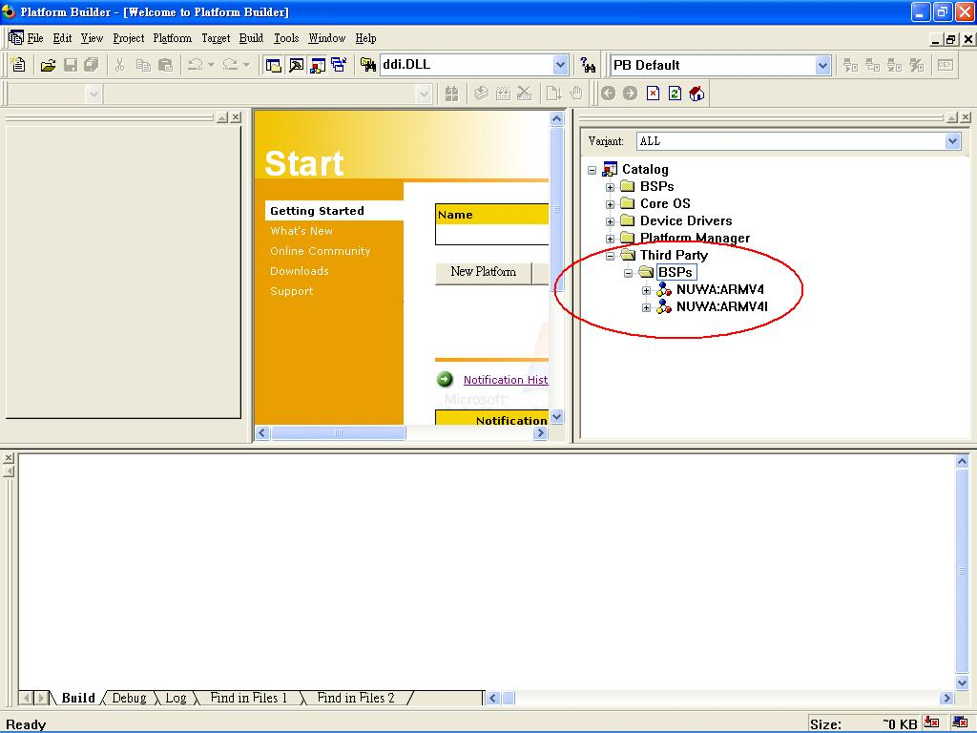

  - Step by step to create a new Platform for NuWa
The following steps illustrate how to create a new platform for NuWa.
Step1: Using Platform Builder to create a New Platform.
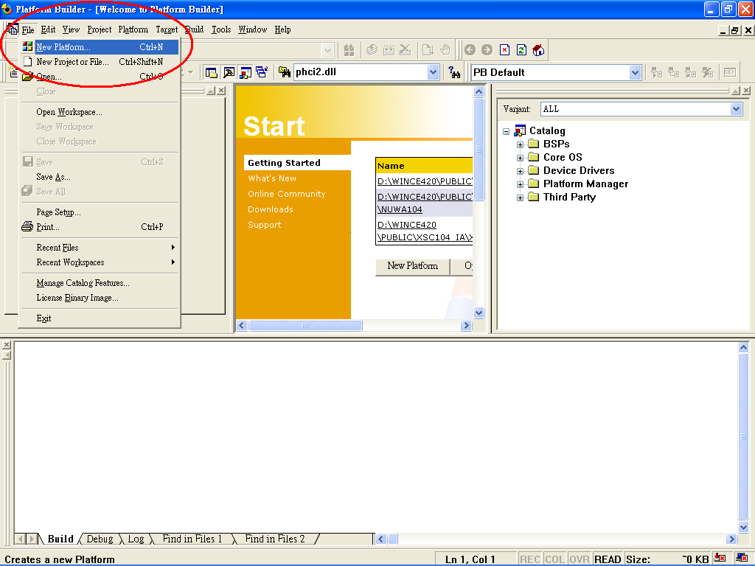

You will see the diagram show as below after you select “New Platform …”
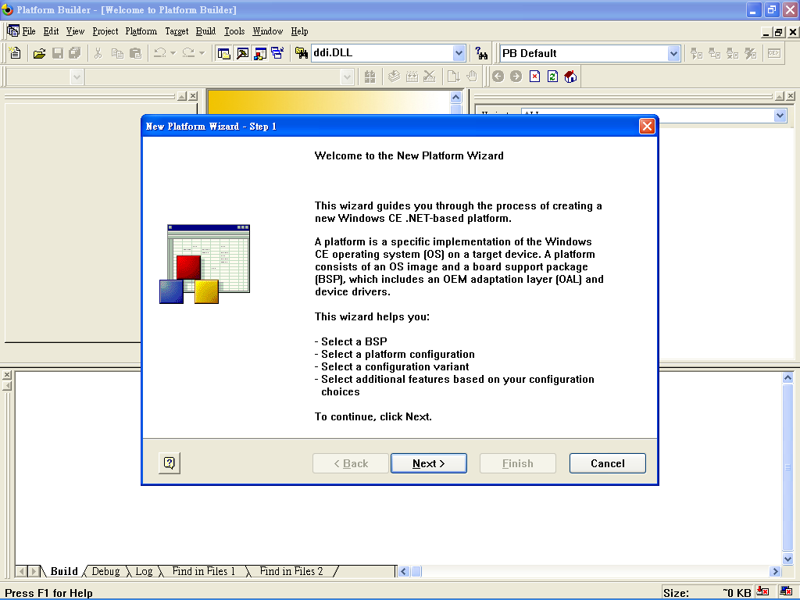
Step 2: Select NuWa BSP to create platform.
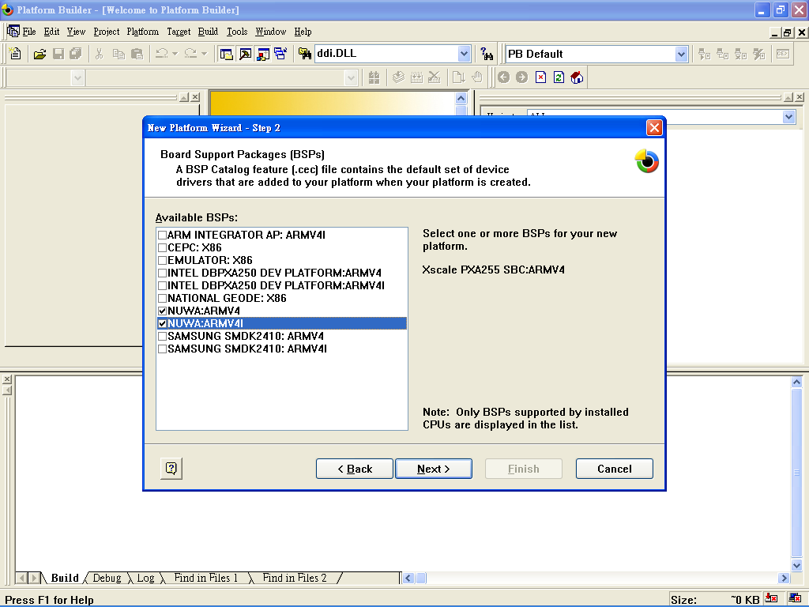

Step 3: Select the platform configuration that most closely matches your application. And enter your platform name.
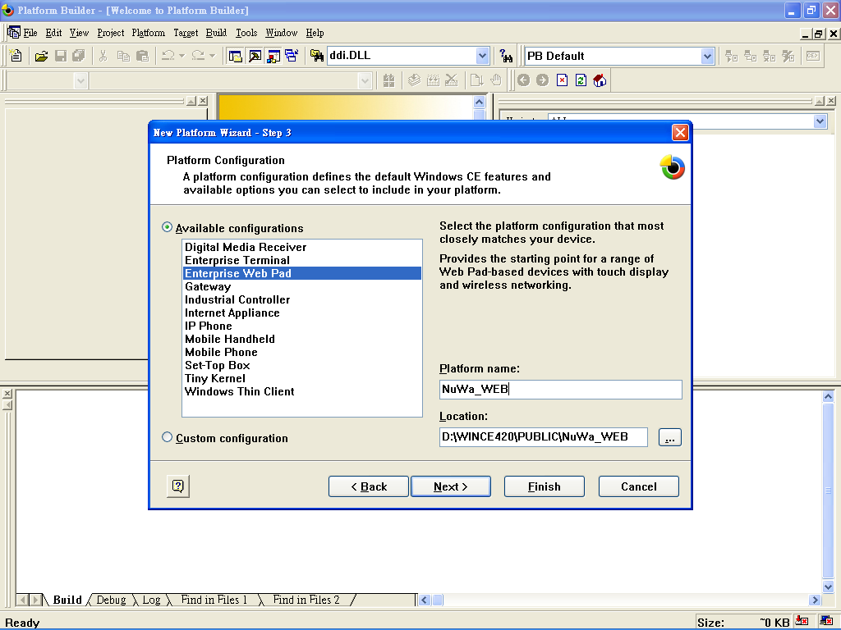

Step 4: Select the application and media options you want to include in your platform.
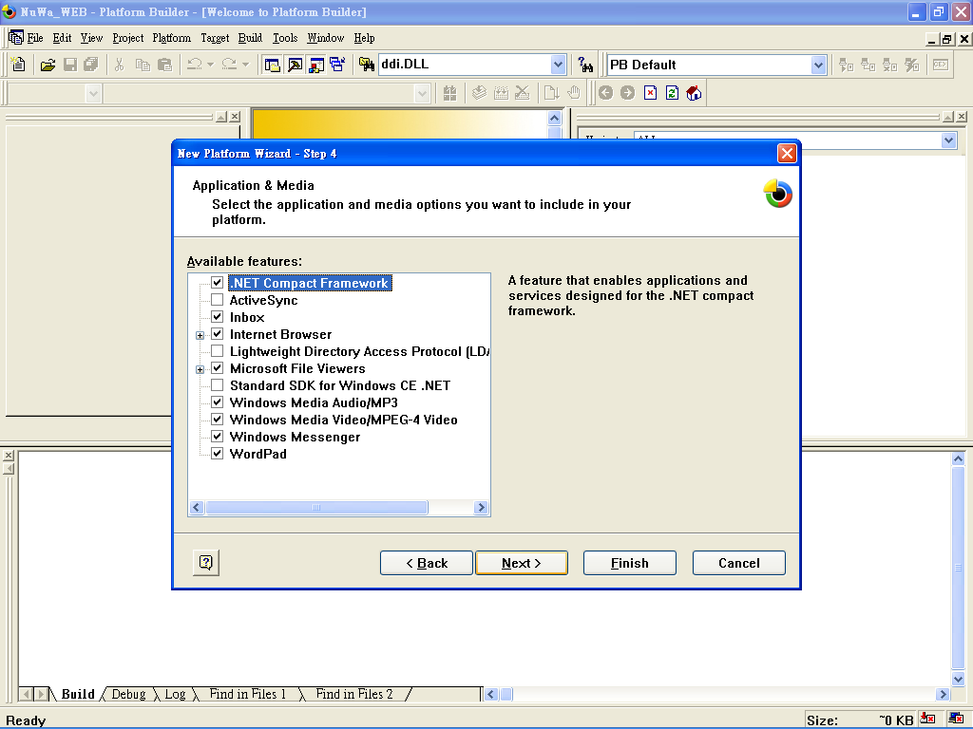

Step 5: Select the networking and communication options you want to include in your platform.
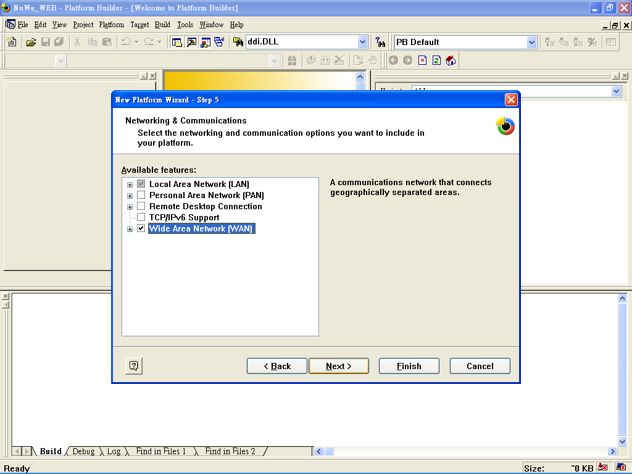

Step 6: Completing the New Platform Wizard.
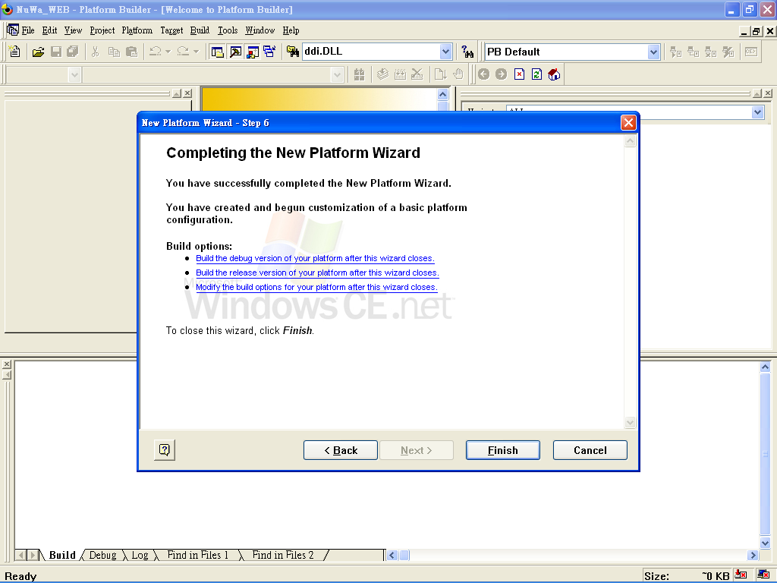

You will see the diagram show as below after we create a new platform.
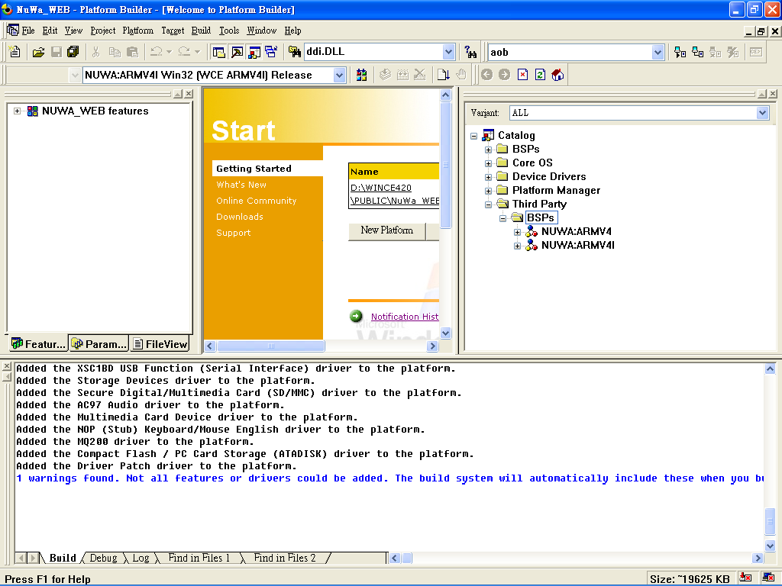

The following steps illustrate how to build OS Image.
Step 1: Select an active configuration we want to build.
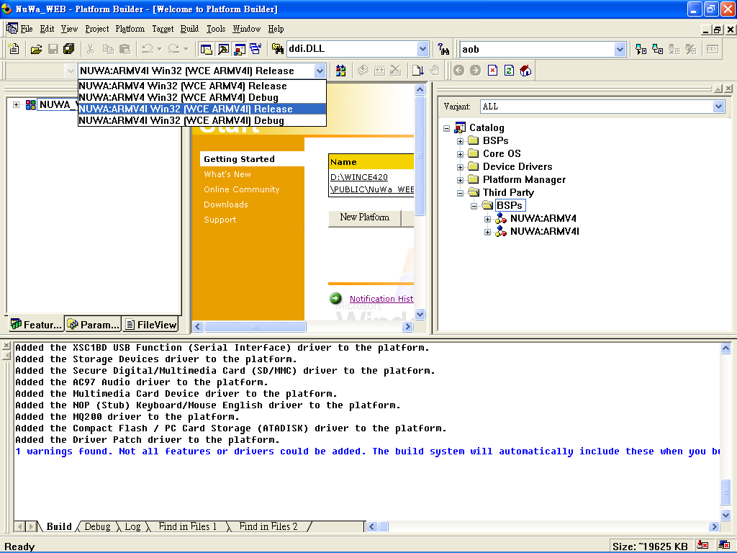

Step 2: Platform Setting. Please set “Enable Full Kernel Mode” at “Build” Options page.
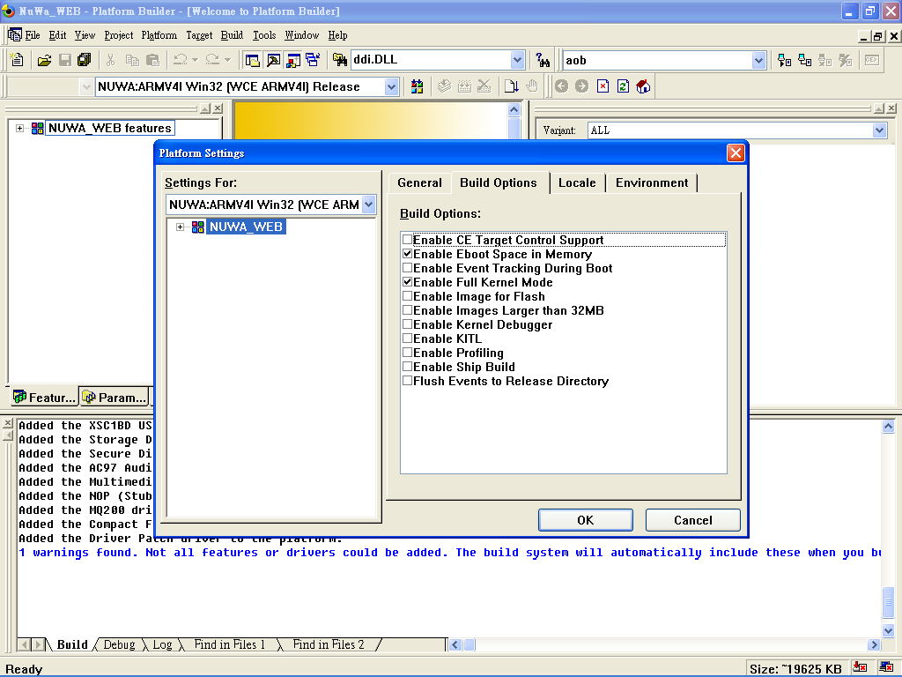

Step 3: Select locates 、Default Language and Codepages at “Locale” Page.
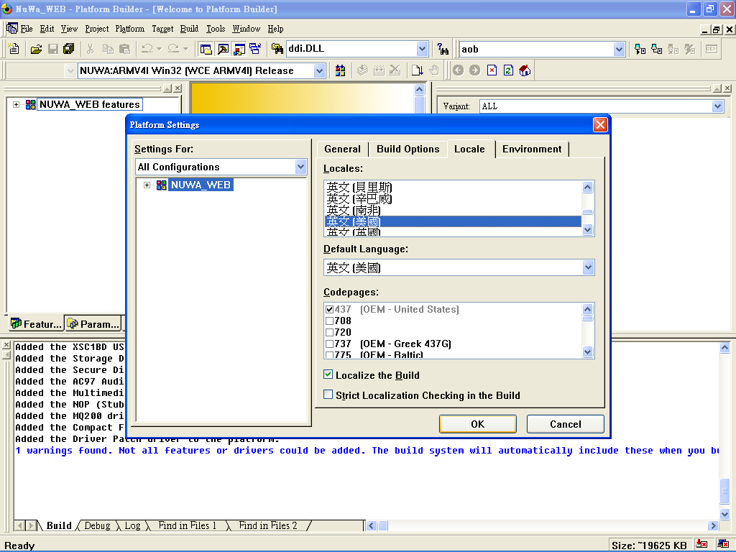

Step 4: Select “Build Platform” to build an OS image.
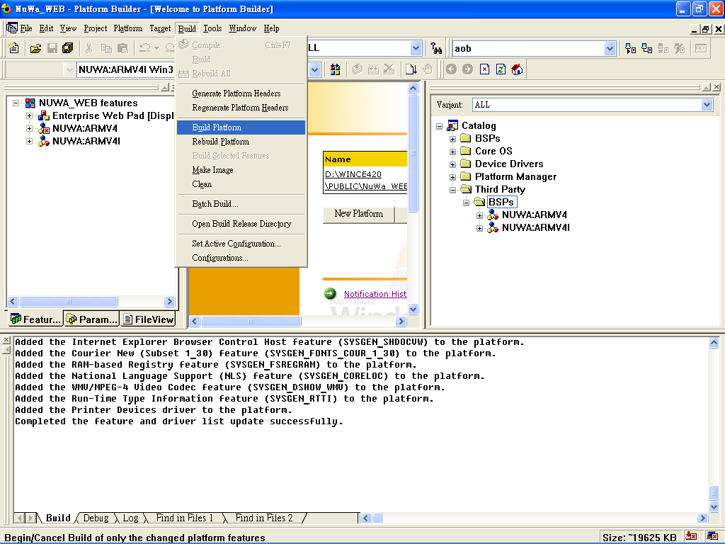
We will get an OS image named “NK.BIN” on our release directory after build platform completed.
2.3 Download OS Image to NuWa
The following steps illustrate how to Downloads OS Image to NuWa.
Step 1: Please turn off NuWa. Then set “Operation Mode Selection Jumper” of NuWa (J36) to “Download OS Image”. (Short Pin2 and Pin3)
J36 | Mode
Short 2-3 | Download OS Image
Short 1-2 | Normal Mode
Open | Normal Mode

Step 2: Connect either one of Ethernet ports (J3 or J4) to DHCP server.
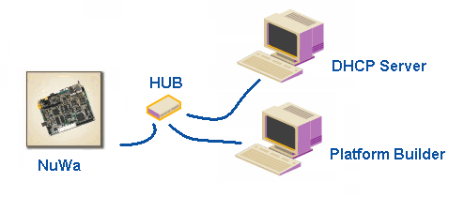

Step 3: Setup “Configure Remote connection”.
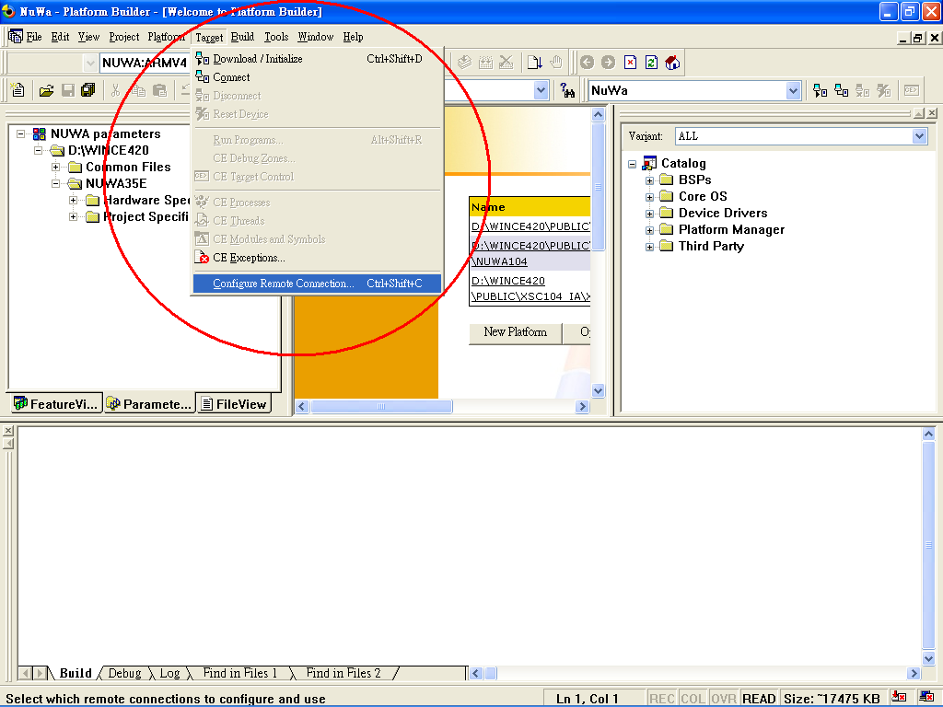
Step 4: Select download mode via Ethernet.
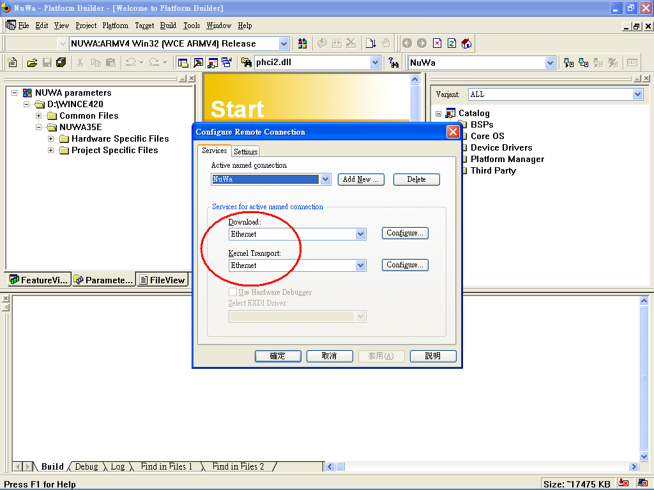

Step 5: Please turn NuWa on. Then setup download configure. We will get a list of available device. And select one of device we want to download.
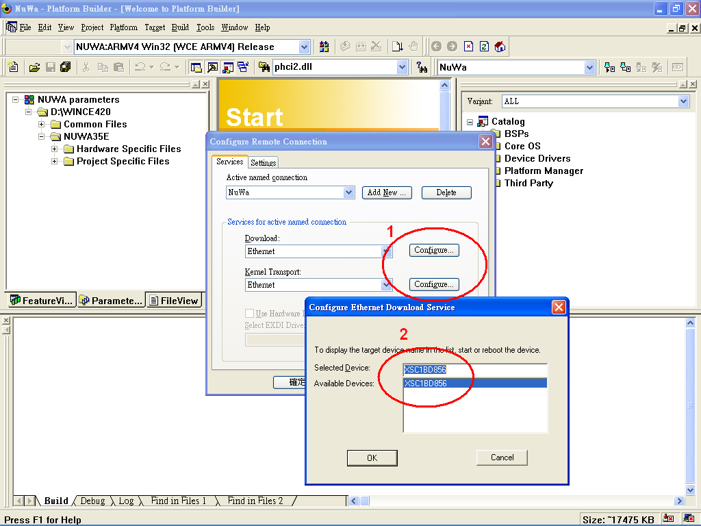

Step 6: Download OS Image.
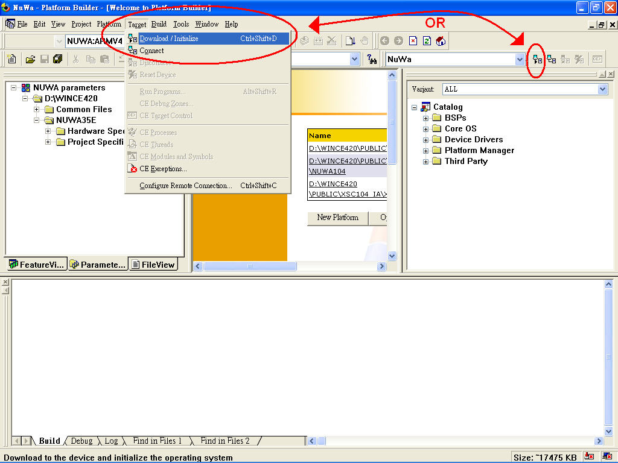

Step 7: Platform Builder is now waiting for “BOOTME” signal from the target device. Then go to Download.
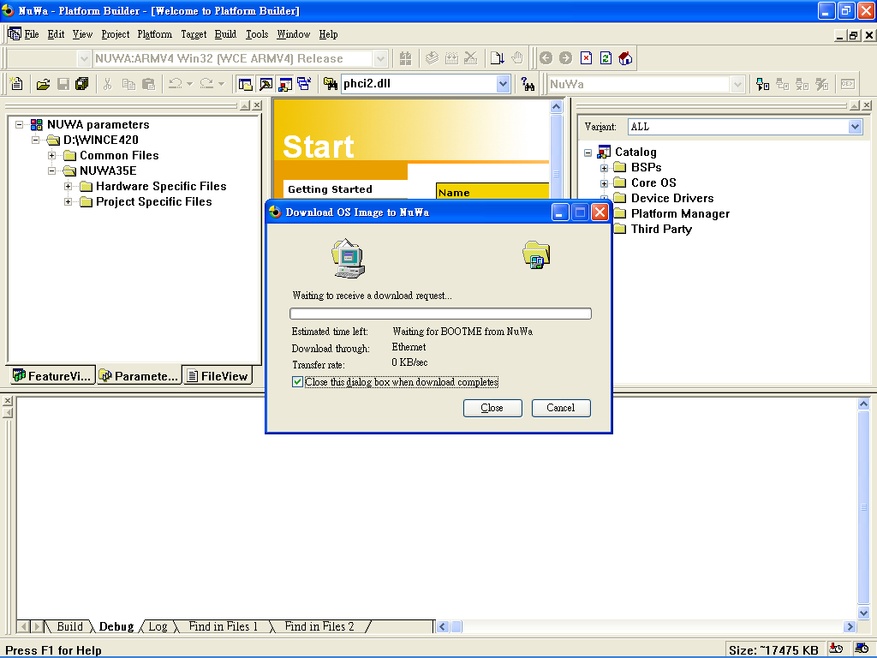
- NuWa Utility
NuWa Utility is a program provide by ICPDAS. It assist user easy to configure 、 setup or update OS image for NuWa. It provides 5 main functions describe as below:
  - Save Registry
It provides 5 sub-functions on this page.
- Resolution:
User can select display resolution over here. The default is 640x480.

- Save and Reboot:
Everything changed must be save registry and will take effect after system reboot.

- Recover to Factory Setting:
It will clear current registry setting and recover to factory default.

- View Registry:
User can use this function to check or verify system registry setting.

- Directory of FTP and HTTP:
This function can change FTP and HTTP directory.
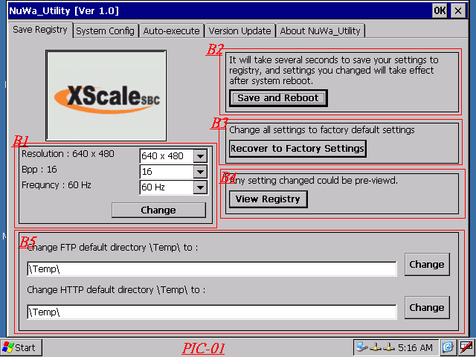
  - System Configure
It will display current system information such as Unique ID Serial Number、 Ethernet MAC Address、OS and SDK Version and OS Image Size. It will display add-on I/O module if I8000 serials I/O Module plug on J25.

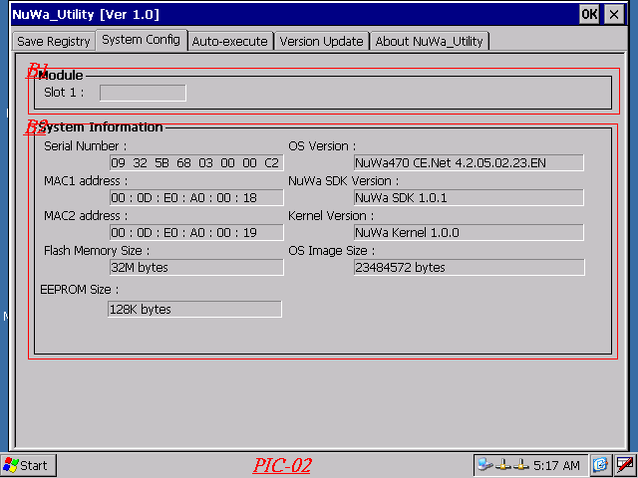

  - Auto-execute
This function provides a scheme allow NuWa to execute User’s application program automatically when system startup.
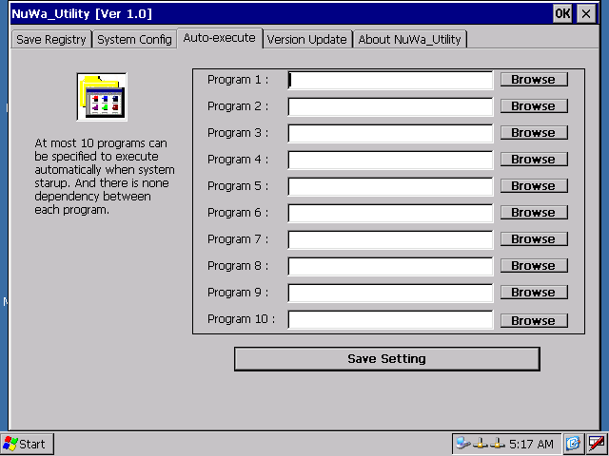
  - Version Update
The Windows CE OS Image is saved on Flash. This function will clear current OS Image and update to a new one.
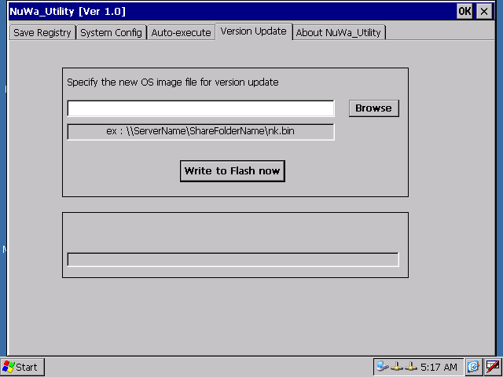
  - About
It will display related information about NuWa Utility.
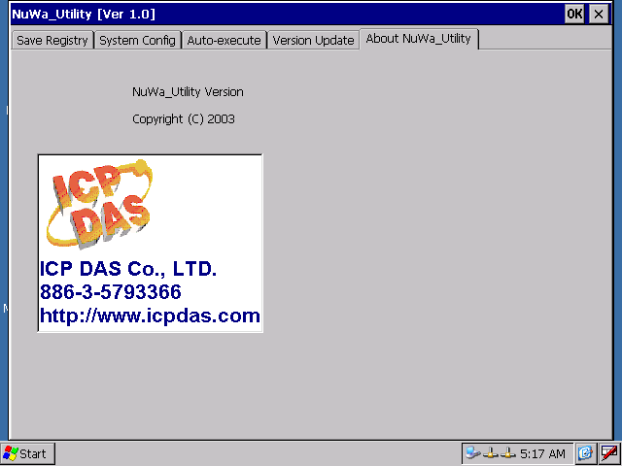
- Installation of NuWa SDK
A software development kit (SDK) is a set of headers, libraries, Help documentation, Platform Manager files, run-time files, and platform extensions that developers use to write applications for a specific platform. The SDK allows developers to create and debug an application on NuWa using Embedded Virtual C++ 4.0 or .NET Compact Framework.
The following step illustrate SDK installation guide:

Step 1: Double click NUWA_SDK.MSI package file to install SDK. Then click “Next”.
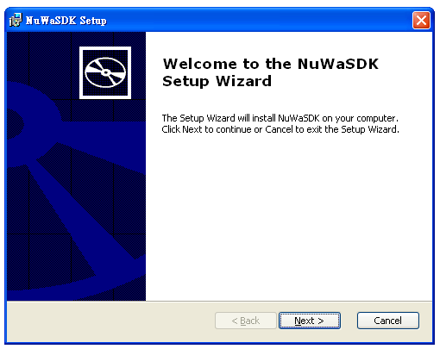
Step 2: Please read License Agreement and then click “Next”.
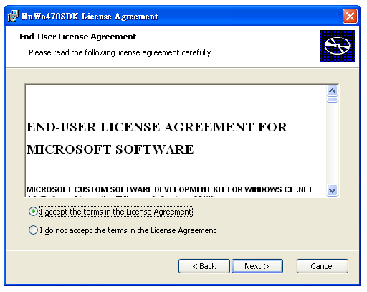

Step 3: Enter customer information. Then click “Next”.
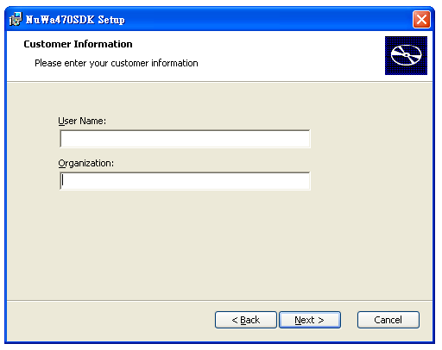
Step 4: Choose setup type. User can choose development program language such as Embedded Virtual C++ 4.0 or .NET Compact Framework. Then click “Next”.
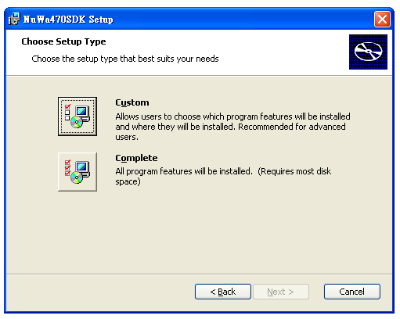
Step 5: Setup destination folders to install SDK. Then click “Next”.
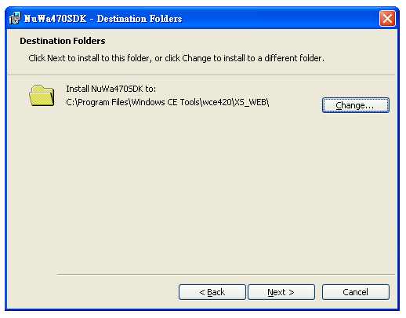
Step 6: Click “Install” to install SDK.
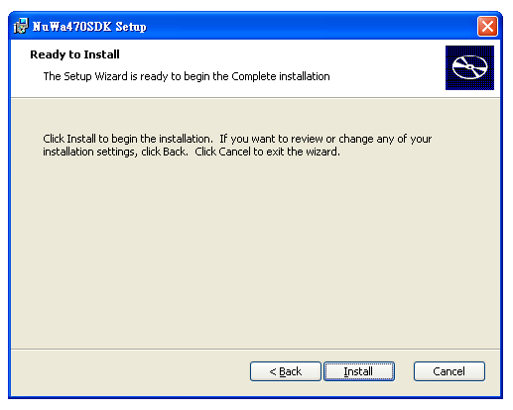

Step 7: Installing SDK.
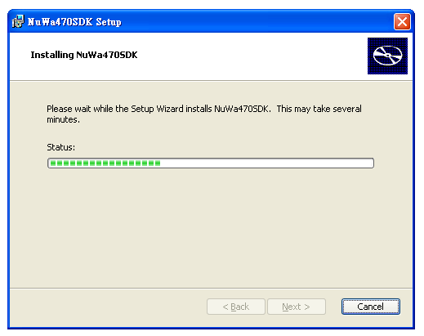
Step 8: Completing the SDK installation.
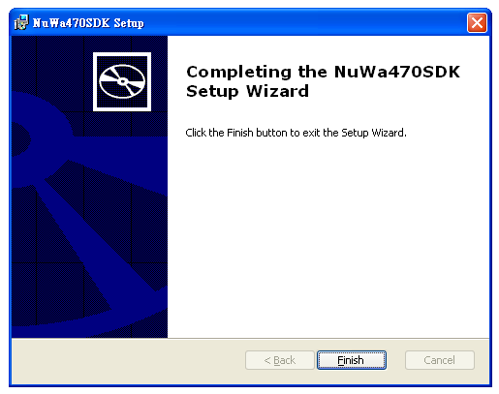

The detail programming information please refers to “NuWa SDK.DOC”.
- Miscellaneous
  - Installation of JTAG
The following steps illustrate how to install JTAG Driver to Windows XP, 2000 system:

Step 1: Copy the GIVEIO.SYS file to: %systemroot%\system32\drivers.

Step 2: Choose Start, choose Settings, choose Control Panel, and choose ‘Add/Remove Hardware’.

Step 3: Choose ‘Next’, select 'Add/Troubleshoot a device' and choose ‘Next’.

Step 4: Select 'Add a new device' and choose ‘Next’, and select 'No, I want to select the hardware from a list'

Step 5: Choose ‘Next’, select Other devices and choose ‘Next’, choose 'Have Disk...'.

Step 6: Choose 'Browse...', locate the folder where GIVEIO.INF, choose 'OK'.

Step 7: Choose ‘Next’, choose ‘Next’ again, and finally choose Finish.
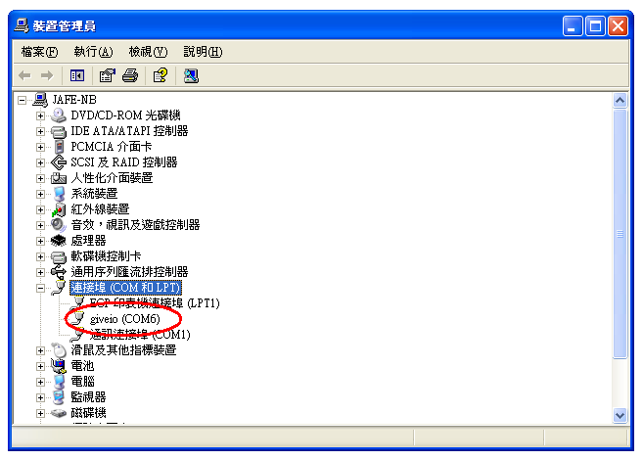
  - Download Boot Loader
Users can use XFLASH.BAT to write Boot Loader to NuWa after JTAG Driver installed. The following steps illustrate how to download Boot Loader to NuWa.

Step1: Install Peripheral I/O cable to connector J1.

Step2: Using a One by One 25 pins PRINTER cable to connect host pc and NuWa.

Step 3: Open a DOS Command window.

Step 4: Change directory to where the XFLASH.BAT at.

Step 5: Using XFLASH.BAT to download Boot loader. The format of XFLASH.BAT is:
XFLASH BOOT_LOADER_FILENAME

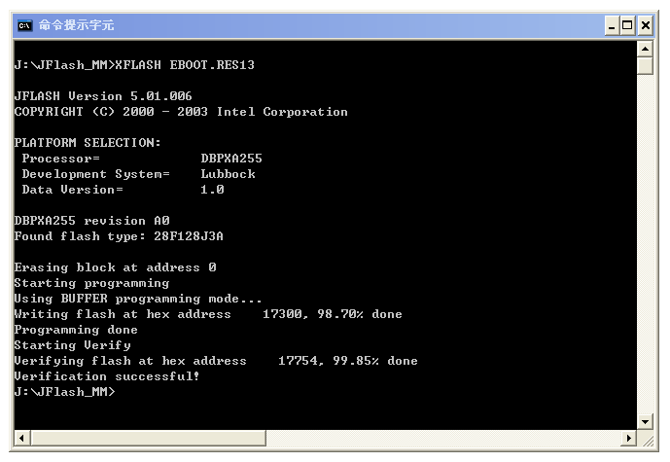
  - Debug Port
NuWa provides a Debug port to display NuWa status via connector J1 (Peripheral I/O Connector). The following steps show you how to use Debug Port:

Step 1: Install Peripheral I/O cable to connector J1.

Step 2: Using a One by One 9 pins RS-232 cable to connect host pc and NuWa.

Step 3: Execute “Hyper Terminal” on host PC.

Step 4: Setting communication parameter:
Baud Rate: 38400
Data Bits: 8 bits
Parity Check: None
Stop Bit: 1

Step 5: Turn the system on. You can see the debug message on “Hyper Terminal”.

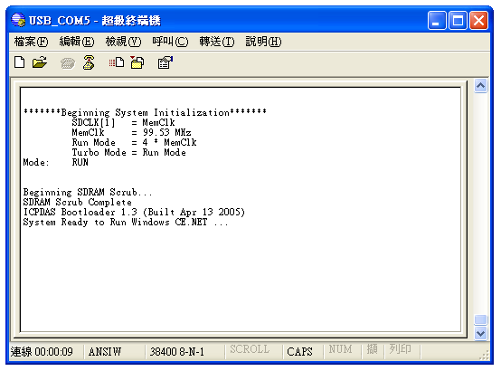
Appendix A: Device Name of Serial Ports

The list illustrates the map of device name in Windows CE.NET.
Device Name | Connector | Function | 430 | 450 | 470
COM0 | J25 | TX/RX for I8000 I/O | ● | ● | ●
COM1 | COM1 | Full Function RS-232 | ● | ● | ●
COM2 | J2 | 2 Wired RS-485 | ● | ● | ●
COM3 | N/A | Reserved for Touch | ● | ● | ●
COM4 | J1 | Blue Tooth | ● | ● | ●
COM5 | J1 | IrDA | ● | ● | ●
COM6 | J1 | USB Client | ● | ● | ●
COM7 | J6 | 2 Wired TTL Level RS-232 | N/A | ● | ●
COM8 | J17 | Full Function RS-232 | N/A | ● | ●
COM9 | J17 | 4 Wired RS-232 | N/A | ● | ●
MSP1 | J17 | 4 Wired RS-232 | N/A | ● | ●
●: Build-in Function

