How to operate the ini file in MiniOS7 system
Part I: Quick start for this demo program.
Please follow steps below to run this demo program.
- There are many applications need to use configure file which know as ini file to provide parameters for program, MiniOS7 library can use on board Flash to store exe file and configure file. This demo will show how to get the string parameter from ini file and then convert to integer, long, float data, also it can convert hex format string to integer or long data.
- In MiniOS7 system, the default Flash can be used as storage device, the default Flash can be separate into disk A and disk B, the default configuration is disk A.
- We can load all exe, autoexec.bat and configure ini file to the same disk A
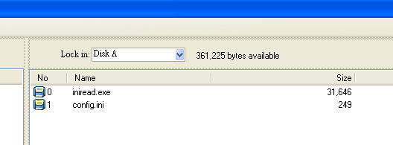
The right executed result will be as below.
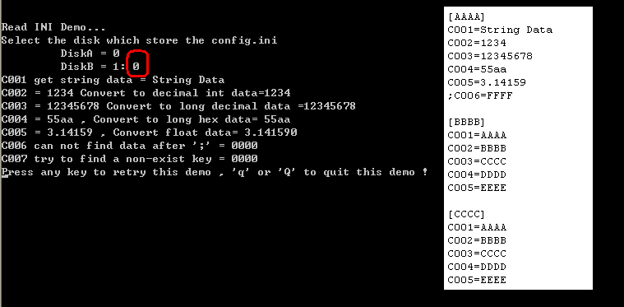
If the configure is not exist in selected disk, the result will be as below.
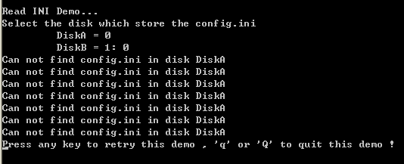
- We can also load exe, autoexec.bat file to disk A and configure ini file to disk B.
please use MiniOS7 utility to set disk as A, and B
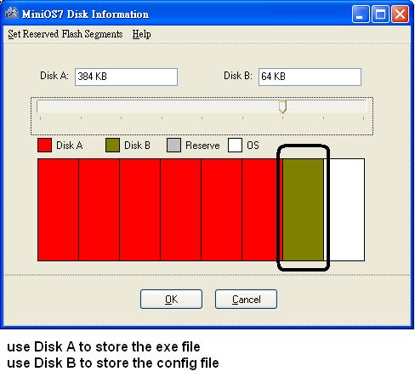
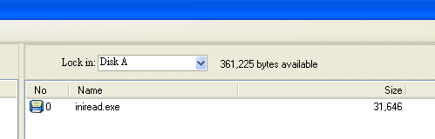
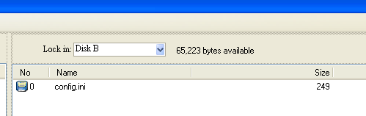
The right executed result will be as below.
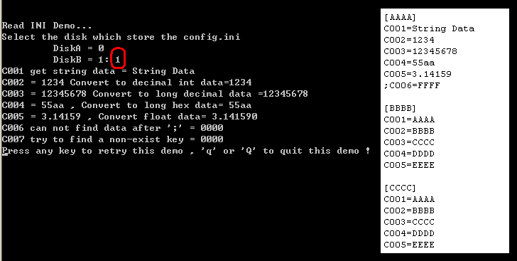
If the configure is not exist in selected disk, the result will be as below.
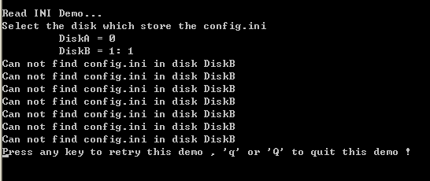

- We don’t use autoexec.bat file in this demo program, we just have one exe file and one config.ini file.
You can follow steps as below to test this demo program.

Part II: Description of API function in this demo.
int GetINIString (char *section, char *key, char *defaultStr,char *returnStr, int buffer_len ,int disk, char *file_name);
The data pattern of ini file will be like
[Section_String]
Key_String = Val_String
Parameters:
section: The name of the section containing the key name. Section of ini file is enclosed by “[“ and “]”
key: The name of the key whose associated string is to be retrieved
defaultStr: if key cannot be found in ini file, then the returnStr will be defaultStr
returnStr: A pointer to the buffer that receives the retrieved string.
buffer_len: The size of the buffer pointed to by the returnStr parameter, in characters.
Disk: 0 diskA ; 1 diskB
File_name: the name of ini file.
Return 0 file not exist in disk, else the size of return string.
Example:
int diskB=1;
int ret=0;
char valStr[32];
ret= GetINIString("AAAA","C001","0000", valStr,32,diskB,"config.ini");
if( !ret ) // means ret ==0
{
Print("Can not find config.ini in disk \n");
}
Else
{
Print("C001 = %s \n",valStr);
}

Part III: Data conversion of string to figure.
The data get from configure ini file is string format, most applications wish to use these string data as decimal/hex format integer, long or float format figures. This demo also shows how to convert them.

String to decimal integer
int iVal;
ret = GetINIString("AAAA","C002","10", valStr,32,disk,"config.ini");
// use sscanf to convert valStr to iVal
sscanf(valStr,"%d", &iVal); // %d as int format
// print the to verify the result.
Print("C002 = %s Convert to decimal int data=%d\n",valStr,iVal);

String to decimal long
long lVal;
ret = GetINIString("AAAA","C003","10000", valStr,32,disk,"config.ini");
// use sscanf to convert valStr to lVal
sscanf(valStr,"%ld", &lVal); // %ld as long format
// print the to verify the result.
Print("C003 = %s Convert to decimal long data=%ld\n",valStr,lVal);

String to hex long
long lVal;
ret = GetINIString("AAAA","C004","10000", valStr,32,disk,"config.ini");
// use sscanf to convert valStr to lVal
sscanf(valStr,"%lx", &lVal); // %lx as long hex format, if int hex format %x
// print the to verify the result.
Print("C004 = %s , Convert to long hex data= %lx\n",valStr,lVal);

String to float
float fVal;
ret = GetINIString("AAAA","C005","0.5", valStr,32,disk,"config.ini");
// use sscanf to convert valStr to fVal
sscanf(valStr,"%f", &fVal); // %f as float format
// print the to verify the result.
Print("C005 = %s , Convert float data= %f\n",valStr, fVal);

